An Interactive Simulation Game

For Teaching Cell Evolution

An Undergraduate Thesis

Presented to the Faculty of the

College of Information and Communications Technology

West Visayas State University

La Paz, Iloilo City

In Partial Fulfillment

of the Requirements for the Degree

Bachelor of Science in Information Technology

by

Uriah De La Cruz

Paul Joseph Debuque

Jeric Glen Pangaban

Zoreen Parcon

Leslie Marie Vargas

May 2023Approval Sheet

An Interactive Simulation Game

For Teaching Cell Evolution

An Undergraduate Thesis for the Degree

Bachelor of Science in Information Technology

by

Uriah De La Cruz

Paul Joseph Debuque

Jeric Glen Pangaban

Zoreen Parcon

Leslie Marie Vargas

Approved:

MARK SOLIDARIOS

Adviser

FRANK ELIFORDE Dr. MA. BETH S. CONCEPCION

Chair, [Division/Dept.] Dean, CICT

# Acknowledgment

The researchers would like to thank with sincerest gratitude and appreciation to the following people, who made this research possible:

Sir Mark Solidarios, assigned adviser for his support and guiding us through the research process. His guidance with his expertise in making game development and the entire process of writing this research was helpful with the completion of this study;

The Faculty and staff of College of Information and Communication Technology, for helping us with questions regarding the study;

The panel members, Prof. Cheryll Ann Feliprada, Prof. Janine Defante, Prof. Erwin Osorio for their recommendations and feedback which help the researchers for improving the applications in order to accomplish the objectives of this study;

The friends and classmate for giving advice and helping with the process of this study;

The supportive parents, whom help the researchers with encouragement and financial support;

Above all, to the great Almighty, who created knowledge and wisdom, for giving the researchers the help they need in order to make this study complete. To God be the greatest glory!

Uriah De La Cruz

Paul Joseph Debuque

Jeric Glen Pangaban

Zoreen Parcon

Leslie Marie Vargas

May 2023

Uriah De La Cruz; Paul Joseph Debuque; Jeric Glen Panganiban; Zoreen Parcon; Leslie Vargas; “An Interactive Simulation Game for Teaching Cell Evolution”. Unpublished Undergraduate Thesis, Bachelor of Science in Information Technology, West Visayas State University, Iloilo City, Philippines, [Completion/Graduation Month and Year].

# Abstract

Understanding biological evolution is challenging because it involves intricate biological processes and time periods that are incomprehensible to mankind. Several video games have made an attempt to illustrate how biological evolution works, but they did not go into enough detail about the specifics of the subject. Even now, humans still don't fully understand how cells evolve and evolved. To better explain in convenience how cell evolution operates, the researchers have developed an interactive simulator game for cell evolution. The researchers have proposed a computer system that can simulate the evolution of cells. The system is developed using a Unity Game engine as a tool for developing the game. A simulation game which focuses on different cell evolutions where the user can choose an evolutionary path and has a dynamic environment that can simulate the harsh environment which past cells lived in long ago.

# Table of Contents

Page

Title Page i

Approval Sheet ii

Acknowledgment iii

Abstract iv

Table of Contents v

List of Figures x

List of Tables xii

List of Appendices xiii

Chapter

1 INTRODUCTION TO THE STUDY 1

Background of the Study 1

Theoretical Framework 7

Objective of the Study 9

Significance of the Study 10

Definition of Terms 12

Delimitation of the Study 16

2 REVIEW OF RELATED STUDIES 17

Related Systems 17

Review of Existing and Related Studies 19

3 RESEARCH DESIGN AND METHODOLOGY 23

Description of the Proposed Study 23

Methods and Proposed Enhancements 24

Components and Design 25

System Architecture 25

Class Diagram 27

Procedural Design 28

Object-Oriented Design 30

System Design Life Cycle 32

4 RESULT AND DISCUSSION 35

Implementation 35

Main Menu Screen 37

Main Game 38

Skill Tree 39

Stat of the Cell 40

Results Interpretation and Analysis 42

System Evaluation Results 45

ISO 25010 - Functional Stability 46

ISO 25010 - Performance Efficiency 47

ISO 25010 - Usability 48

ISO 25010 - Reliability 49

ISO 25010 - Portability 50

Summary of ISO 25010 51

5 SUMMARY, CONCLUSIONS, IMPLICATIONS 54

AND RECOMMENDATIONS

Summary of the Proposed Study 54

Design and Implementation

Summary of Findings 55

Conclusions 56

Recommendations 57

References 58

Appendices 63

List of Figures

Figure Page

1. System Architecture of the Proposed 5

System

2 System Flowchart 6

3 System Architecture 26

4 Class Diagram 27

5 Flowchart 29

6 Activity Diagram 31

7 Game Design Life Cycle 33

8 Main Menu Screen 37

9 Main Game 38

10 Skill Tree 39

11 Stats of the Cell 40

# List of Tables

Table Page

1 In Game Evaluation Results 43

2 Mean Score Interpretation 44

3 ISO 25010 - Functional Stability 46

4 ISO 25010 - Performance Efficiency 47

5 ISO 25010 - Usability 48

6 ISO 25010 - Reliability 49

7 ISO 25010 - Portability 50

List of Appendices

# 

Appendix Page

1. Letter to the Adviser 63
2. Letter to the Evaluators 65
3. Letter to the Grammarian 66
4. Gantt Chart 68
5. Source Code 69
6. ISO Questionnaire 74
7. Disclaimer 7

Chapter 1 INTRODUCTION OF THE STUDY

Background of the Study and Theoretical Framework

Biological evolution is a difficult concept to learn because it involves complex biological mechanisms and time periods that are well beyond human comprehension. One part of biological evolution are cells. Ever since cells were first discovered by Robert Hooke in 1665 using an improved microscope, the world has come to learn a lot more about cells. Another topic is how cells evolved and developed into complex cells that would then help each other to become multiple living organisms that would eventually inhabit the Earth. However, the knowledge concerning the topic of cell evolution and how it started remains incomplete to this day. As such, it is difficult and challenging to know exactly how cell evolution started and how it works. Multiple games have tried to explain how biological evolution works but have not explored the in-depth details of the topic. One notable game, Spore, shows how life would first start from a tiny cell form and then evolve to become a space-faring civilization but it just simplified other life mechanics to make it an enjoyable game to play. One of the lacking parts of the game is its simplified implementation of cell evolution into the gameplay mechanics, resulting in it giving a vague explanation of how the life form evolved and grew into a planet conquering civilization. What the researchers wanted to do is to create a simulator game that would educate people more about what we know or currently think about how cell evolution works. Creating this educational simulator game would help in teaching biology majors or those who are interested in cell evolution to understand more about the topic. Using a simulator game, as a medium to help educate students and people who are interested in the subject, could also encourage, motivate and allow students to learn at their own pace.

Abiogenesis is the natural process by which living organisms arose from nonliving organic molecules (Markgraf, 2019). This is where the game would start. The player would begin as a single-celled organism where the first goal is to gather and consume proteins or nutrients from the surrounding. After some time gathering energy the player’s cell then can evolve into prokaryotes. Depending on how the player’s cell gets its nutrients, it would grow to prefer one of the two types of metabolic processes: Phototrophs or Chemotrophs. Phototrophs obtain their energy from sunlight while chemotrophs obtain theirs from chemical compounds. Players can also choose whether they would produce or consume to get their source of energy; they are called autotrophs, those who produce, and heterotrophs, those who consume (Georgia Tech Biological Sciences, n.d.). After some time the player’s cell would then evolve into either archaea, bacteria, or eukarya(eukaryotes). These choices would affect how the player survives in the upcoming new environments. Depending on the player’s playstyle during this new evolution they would have different routes on how they would survive in the upcoming stage. The next stage would be the start of the Oxygen Revolution. If the player decided to become an anaerobic cell they would have a tough time trying to find a location where there is less oxygen content as it would be toxic while those whose playstyle revolves around being aerobic would have an easier time during the Oxygen Revolution. After that stage, the player is then informed if they want to keep going with that play style or start a symbiotic relationship with another cell becoming a eukaryote. What this refers to is the endosymbiotic theory, where cells evolve to become a eukaryote when multiple cells join together into one (Warring, n.d.). They would have this interesting mechanic where they become a whole new cell form due to this symbiotic relationship. Another mechanic they could also have is if they consume other cells to receive the DNA of their food and then use that DNA to evolve into a better cell form. As for now, these are the current plans/features that are to be developed.

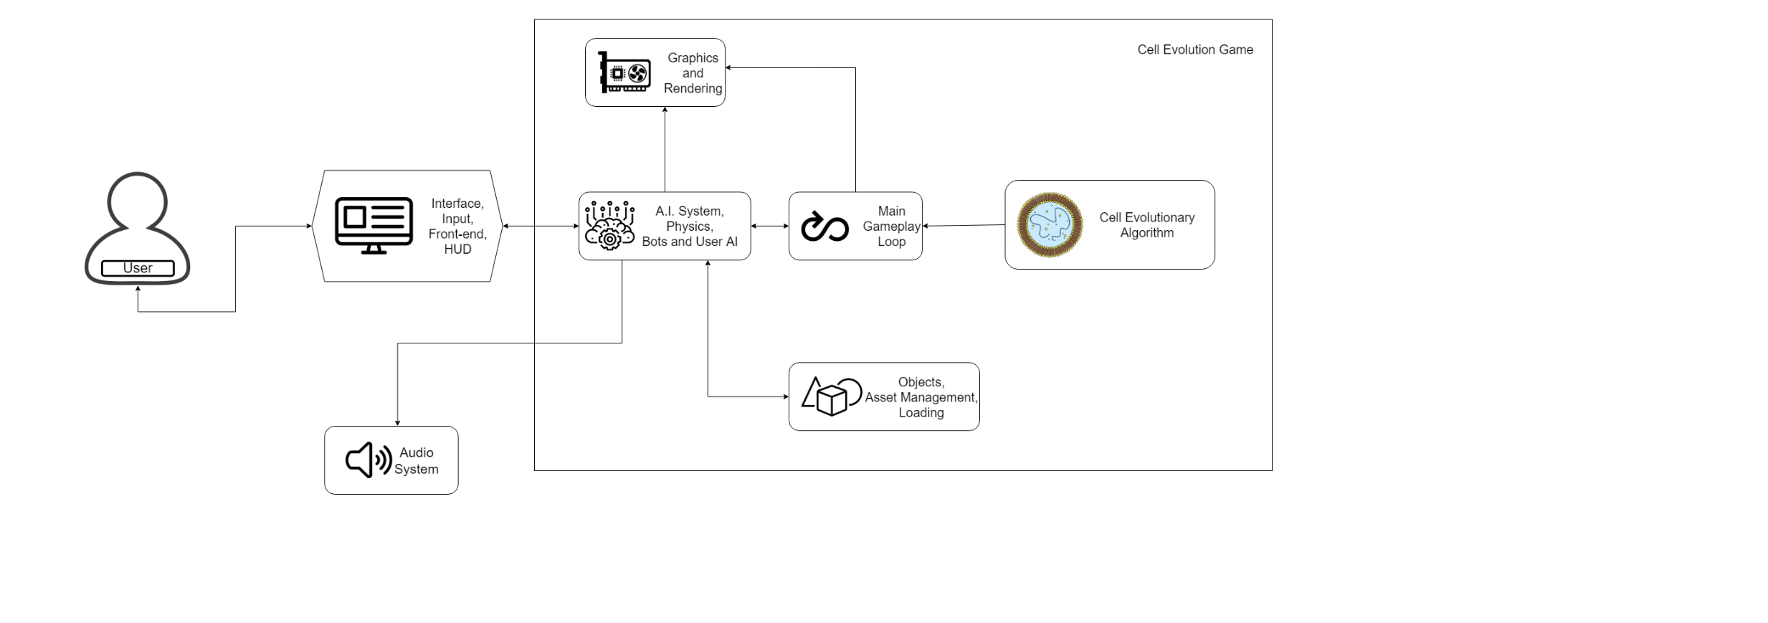

**Figure 1.** System Architecture of the Proposed System

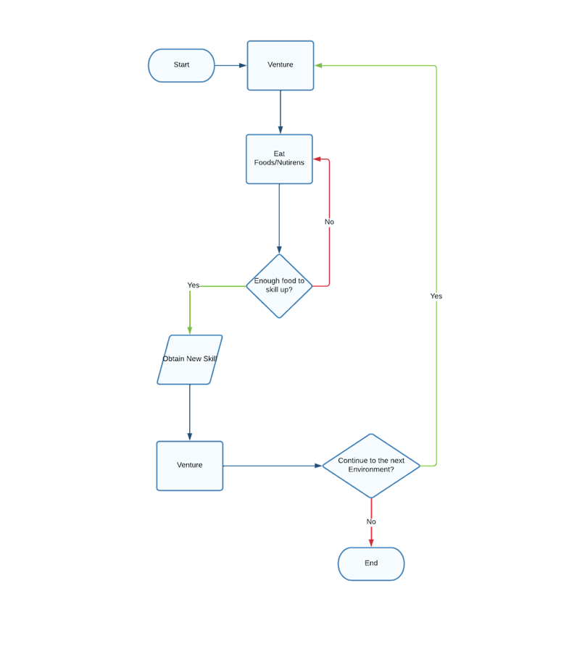

**Figure 2.** System Flowchart

Theoretical Framework

Cell Evolution is a difficult topic to discuss leading to poor knowledge and low interest in the subject. Its complexity and need for deep understanding of the topic makes learning quite difficult and the same could be said to teaching it. Furthermore, not everything is known for certain about the subject, hence, an alternative way of teaching the topic is considered through games.

Vlacchoupolos (2017), states that games teach you different skills that you take in the real world such as practical skill, task management, and decision making.

Games have previously been considered as a tool to teach individuals certain topics. As such, efforts in trying to develop a video game about the subject interested game developers. One example would be the video game Spore by Electronic Arts, which delved into the concept of a cell gradually evolving throughout the course of the game. However, the game was more of a video game than a learning tool.

In this study, the researchers shall develop an educational simulation game in order to simulate the primordial cells, the environment they live in, and the various events and conditions that would allow it to evolve. The simulation game will teach cell evolution and its related concepts through game mechanics such as a Levelling System and a Skill Tree. With these challenges, the researchers will make use of simulation type games in order to portray the game as an educational cell evolution game.

Objectives of the Study

The researchers of the study aim to develop and determine how effective a cell evolution simulator game will be as a teaching aid.

Specifically, this study has the following objectives:

1. To create a simulator game that would focus on cell evolution and will include features such as multiple evolutionary paths, and dynamic environment.

1. Implement Cell Evolution concepts such as Abiogenesis, Cell Theory, Phagocytosis, and Endosymbiotic Theory into the Narrative and Gameplay Mechanics.

1. Record gameplay choices and statistics such as dietary path, evolutionary path, and survival tactics.

Significance of the Study

The following are the beneficiaries of the proposed system:

  People with less knowledge about cell evolution and how cells adapt to different environments. The individuals will use the system to have an interactive and efficient way to teach them and understand the different ways a cell can evolve.

  To the students in High School or College level that are interested in the different way a cell evolves and how they can survive in different environments. This will help them in studying and learning specific and complex topics of cell evolution.

  The system may be used as a teaching tool for biology teachers that intend to teach cell evolution. The game will provide necessary information about the different ways a cell can evolve, the requirements it needs to evolve, and their evolutionary paths.

Future game developers and researchers may improve the study by using it as a reference tool for the different evolutions of life on Earth.

Definition of Terms

***Abiogenesis Theory*** —- abiogenesis theory or the biopoiesis is a theory in which the scientists conclude that all the living organisms on Earth arise from nonliving matter like simple organic compounds (Planetary Sciences Inc., nd).

  In this study, the proposed study will adopt the theory by incorporating the organic compounds found in the environment, and the protagonist will consume them and evolve into a mature cell.

***Cell*** —- cell is the smallest unit of a living organism and all of the tissues that makes up the entire body. It also houses DNA and RNA which is a unique part of every organism (National Cancer Institute, nd).

  In this study, the cell will be used as our main protagonist as it will be the one that will evolve into a different life form unique to others due to its food intake, the evolution process, and the skills that it acquires during its evolution phase.

***Cell Theory*** —- a theory that the organism is made up of cells and the cells are the basic units of life. In modern cell theory, DNA is passed between the cells during cell division, that cells of similar species are mostly the same structurally and chemically, and that energy flow happens within a cell (National Geographic Society, 2020).

  In this study, the theory is applied by incorporating the idea that the cell is the basic unit of life and the building blocks of genetic formation in every organism with the same species line.

***Endosymbiotic Theory*** —- a theory in which the eukaryotic cells came from prokaryotes. The theory states that when prokaryotes evolve into another being, they will develop a structure like the mitochondria which is known as the powerhouse of the cell (Bodyl, Mackiewickz, Ciesala, 2013).

  In this study, the theory will be applied and conducted as the protagonist will evolve from a cell with no membrane into a cell with parts that acts as its foundation as it progresses and consumes all food that it requires.

***Phagocytosis*** —- phagocytosis is a process of consuming the materials around the cell using it as a defense mechanism that will kill unwanted materials in the environment. The material that will be consumed must be in contact with the cell, if it is not, the process will not take place (Harris, nd).

  In this study, Phagocytosis is used as both the offense and defense mechanism of the protagonist as it will encounter other life forms and different materials that will compete for the food it will eat. It is also important to incorporate the process for the protagonist to live longer in an environment full of danger.

***Simulation Game*** —- a simulation game is a subgenre of a game in which the player controls the protagonist’s actions based on experiences gained in a real-life scenario. The player can choose a different path, different sets of skills, and the way that the game will end. It is also meant to simulate real-life events without using many resources (Boller, 2014).

  In this study, the researcher will develop a simulation game that will simulate the evolution of cells which will include different perks or skills, a dynamic environment that the character will play in, and different sources of energy/food. The proposed study chose a simulation game for it can be used as a learning tool for the evolution of cells.

***Unity Game Engine*** —- The Unity Game Engine is a cross-platform engine that can be used to develop games, simulations, and other similar experiences. It uses C# as the programming language for developers to create and write the code for their games (Sinicki, 2017).

  In this study, the researcher uses the Unity Game Engine as the tool for developing the proposed system which is a simulation game. The researchers chose the Unity Game Engine as it is the most flexible and accessible IDE in the mark

Delimitation of the Study

The study focuses on developing a game that can simulate and teach the biology student about the evolution of the cell that uses unity 3D as a tool to develop the app. The system is developed using a Unity Game engine as a tool for creating the game. It will run on Windows 7 and above with a processor of higher speed and at least 2GB memory of RAM.

The proposed system is a game-based application for which an internet connection is not required to play the game. The system has multiple preset NPCs in the game who will serve as obstacles and competition to the protagonist. It is also a game that can distract the user from real-life activities and can use it as a learning tool.

The user may also need knowledge of simulation games and how certain functions work as some mechanics and controls may be difficult to understand, especially for a beginner.

Chapter 2 Review of RELATED STUDIES

## Review of Existing and Related Studies

Related Systems

Spore is a Computer-based game wherein you are a tiny organism that wants to survive in a world full of creatures that also want to survive. The mechanic of the game is survival to the fittest and you can create your path of evolution however you like (Electronic Arts, 2018). The proposed system is more like a living organism that existed on the planet millions of years ago that wants to evolve by itself. The proposed system has a skill tree in which the user can select their preferred path in order to survive in the harsh environment that they lived in the past. The skills that the user acquired is needed for the survivability of the chosen cell which varies depending on the stats or the passive effect of the skill. The skills have different effects that the primitive cells adopted in the past in order to be the survivor.

Species: Artificial life, real evolution is a simulation that allows the user to create, destroy, observe, and tinker with the protagonist’s life. The game also creates a different environment and different types of species that depend on the user’s action. The researcher’s study focuses on a single cell to interact with and eventually, it will evolve into a different species differing from its predecessor depending on the environment, temperature, or the situation the cell is experiencing (Quasar, 2018).

The proposed system that evolves opponents for interesting interactive computer games is a system in which the predator/prey interact with each other by the user’s action. It is a system that predicts the user’s next action of its player and the opponent will catch up to it and the game will be effective against a player with a strategy (Yannakakis, Hallam, 2004).

As the cell evolves to a different species and multiplies it is bound to encounter opponents that will steal its nutrients to evolve. By avoiding these predators to further evolve into a greater species that will eventually be the predator of the said creature. Enemies of the cell are unique to the user’s cell in that case the enemy will catch you and eat you when you are near in the vicinity of your cell. The user must avoid these enemies in order to eat peacefully and avoid being killed in the process. The proposed system also records your statistics which can show different skills that you acquired and be able to show its effect on each skill.

Related Study

The cells have two main classes if they have a nucleus or not. Eukaryote and Prokaryote cells are what they are called respectively. Cooper(2000) said that many multicellular organisms came from a unicellular eukaryote. The eukaryotes came into existence 1.7 billion years ago and it continues to evolve depending on the environment. Food and survivability are also the cause of the evolution of the cells.

Cellular evolution is a complex matter which results in a decrease in the knowledge of the evolution of the cells. But the complexity of the cell’s evolution makes up for an interesting topic. Cell evolution is a self-limiting process in which it evolves into a new organism, it also changes its structural integrity and its flexibility to adapt to a certain degree (Woese, 2002).

Mitochondria is one of the parts of a cell and scientists believe that mitochondria originated from the primitive cell acquired during their endosymbiosis. When cells evolve, the mitochondria also learn to evolve like some of the genes of the endosymbiont transferred to the nucleus of the cell. Another theory arose for when the mitochondria develop that the mitochondria is a prokaryote which explains that it is the ancestral mitochondrion that was metabolically versatile, which the mitochondria use as a facultative anaerobe.

Eukaryotes have genes that they inherited from their host. They possess similar genes from the endosymbiont which have a mitochondria embedded in their genes. The mitochondria has many proteins in their system encoded in the nucleus which the transfer of the genes to host acquired the proteins which the scientist believed that it is nothing unnatural to the cell that affects its structural behavior.

The oldest cell is these single-celled bacteria. At that time, many bacteria populate the earth and some of them make their nutrients to stay alive. Many single-celled bacteria consume the energy of the sun which is one of their primary sources of energy and the process is called photosynthesis which in the end, will produce oxygen enough to change the atmosphere. When the oxygen is enough, some of the single-celled bacteria evolve and use oxygen as their source of energy, it evolves into an oxygen-breathing life (Learn Genetics, nd).

The endosymbiosis theory was validated by Dr. Lynn Margulis, she is responsible for the theory. She uses a modern technique for molecules which she can examine and see the relationship between the organelles and the structural form of the bacteria. The DNA sequence of the bacteria were similar to the prokaryotic cell which is an insight that the two of them were related to each other in the past before branching out as a unique and individual cell.

In the past, the cells of a living organism were not clearly stated what is the content of the cell and what they consume in order to survive in their respective environment. When the time passes, many of the scientists that study about the cell progressively foresaw what the cell in the past and what they look like.

The eukaryotes according to paleontology were alive during the Earth’s early life approximately 2 billion years ago. The fossils that have been found were similar to the algae and protozoa in the modern age. In line with this, the cells were a proof that the evolution of the cell is depending on the condition and the living environment that they can adapt and survive.

When cells lived in the past, they lived in an environment that only they can survive in. For some reason, some cells evolved and adapted to the environment that they lived in. The scarcity of the food became prevalent and they opted to consume other cells that are smaller than them. They used that in order to survive in the environment.

Chapter 3 RESEARCH DESIGN AND METHODOLOGY

Description of the Proposed Study

The study aims to develop a game that tackles cell evolution. The study focuses on developing a computer-based game application with the following features:

An application that focuses on cell evolution and how it evolves into different organisms.

The application features a different skill path in order for the protagonist to survive in any given environment.

The proposed system will also store the score of the player and the skills of the cell that it acquired during its game time.

Methods and Proposed Enhancements

The proposed system is a game that will simulate the experience of the evolution of a cell. The game itself is a simulation in which you create your own path of evolution depending on game play and skills chosen. It also includes different biology concepts that will be incorporated into the game.

Evaluation of the game is important so that the proposed system is accurate to the cell evolution. The ISO-standard evaluation form will be used. The evaluation form includes five criteria to be judged. To create and correspond to each criterion, a table has been made.

Weight Description

5 Outstanding

4 Very Satisfactory

3 Satisfactory

2 Fair

1 Poor

Components and Design

*System Architecture*

The system architectural design of the proposed system shows the software and hardware configuration and how they are connected to each other.

Figure 3 shows the system architecture of the proposed system. First, the user will start the game in the main menu interface and it will proceed to the game itself. When the game starts its intended function, the user uses a mouse to interact with its foods and its enemies which can contest the food that it will need.

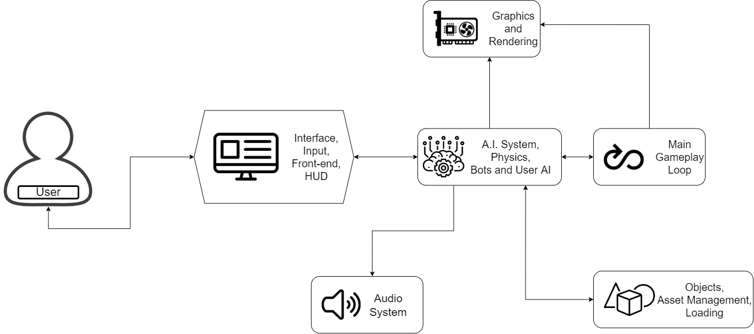

*Figure 3: System Architecture*

*Class Diagram*

In this section, the process of the data model of the proposed system’s database is presented in the independent tables which store data with the

Relationship.

Figure 4 shows the class diagram of the proposed system.

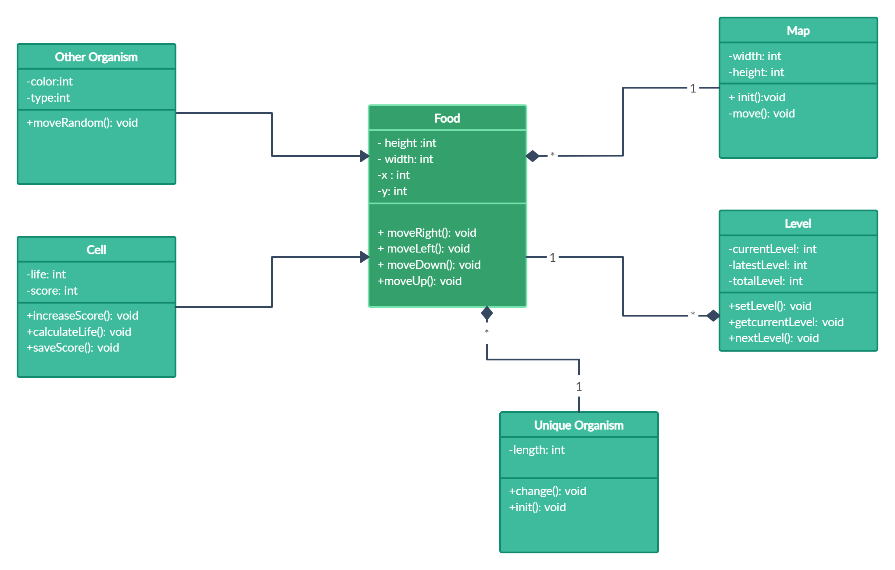

Figure 4. Class Diagram

*Procedural and Object-Oriented Design*

Procedural Design

The procedural design uses a flowchart to indicate the procedure or flow of the proposed system. The flowchart shows the main gameplay loop of the proposed system.

Figure 5 shows the flowchart of the proposed system

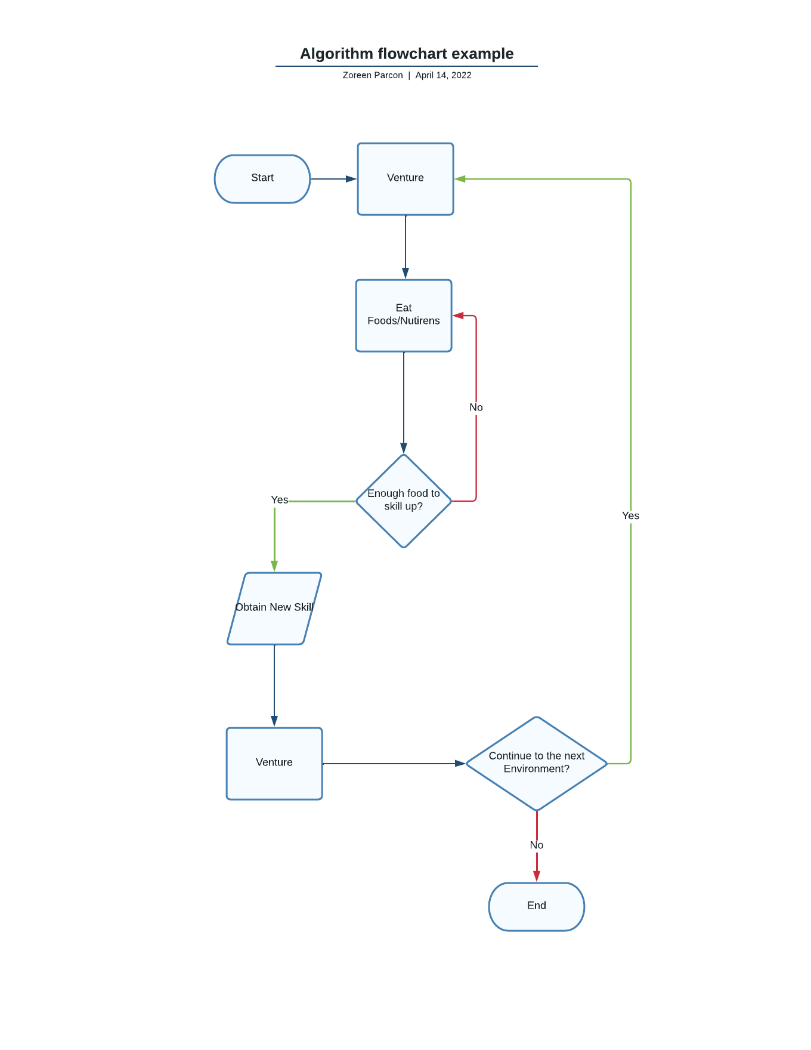

Figure 5. Flowchart

Object-Oriented Design

The object-oriented design, using an activity diagram, is the process of planning a system interacting with objects for the purpose of solving a software problem. The activity diagram describes the set of activities present in the proposed system. It includes the user which is the player.

Figure 6 shows the object-oriented design of the proposed system.

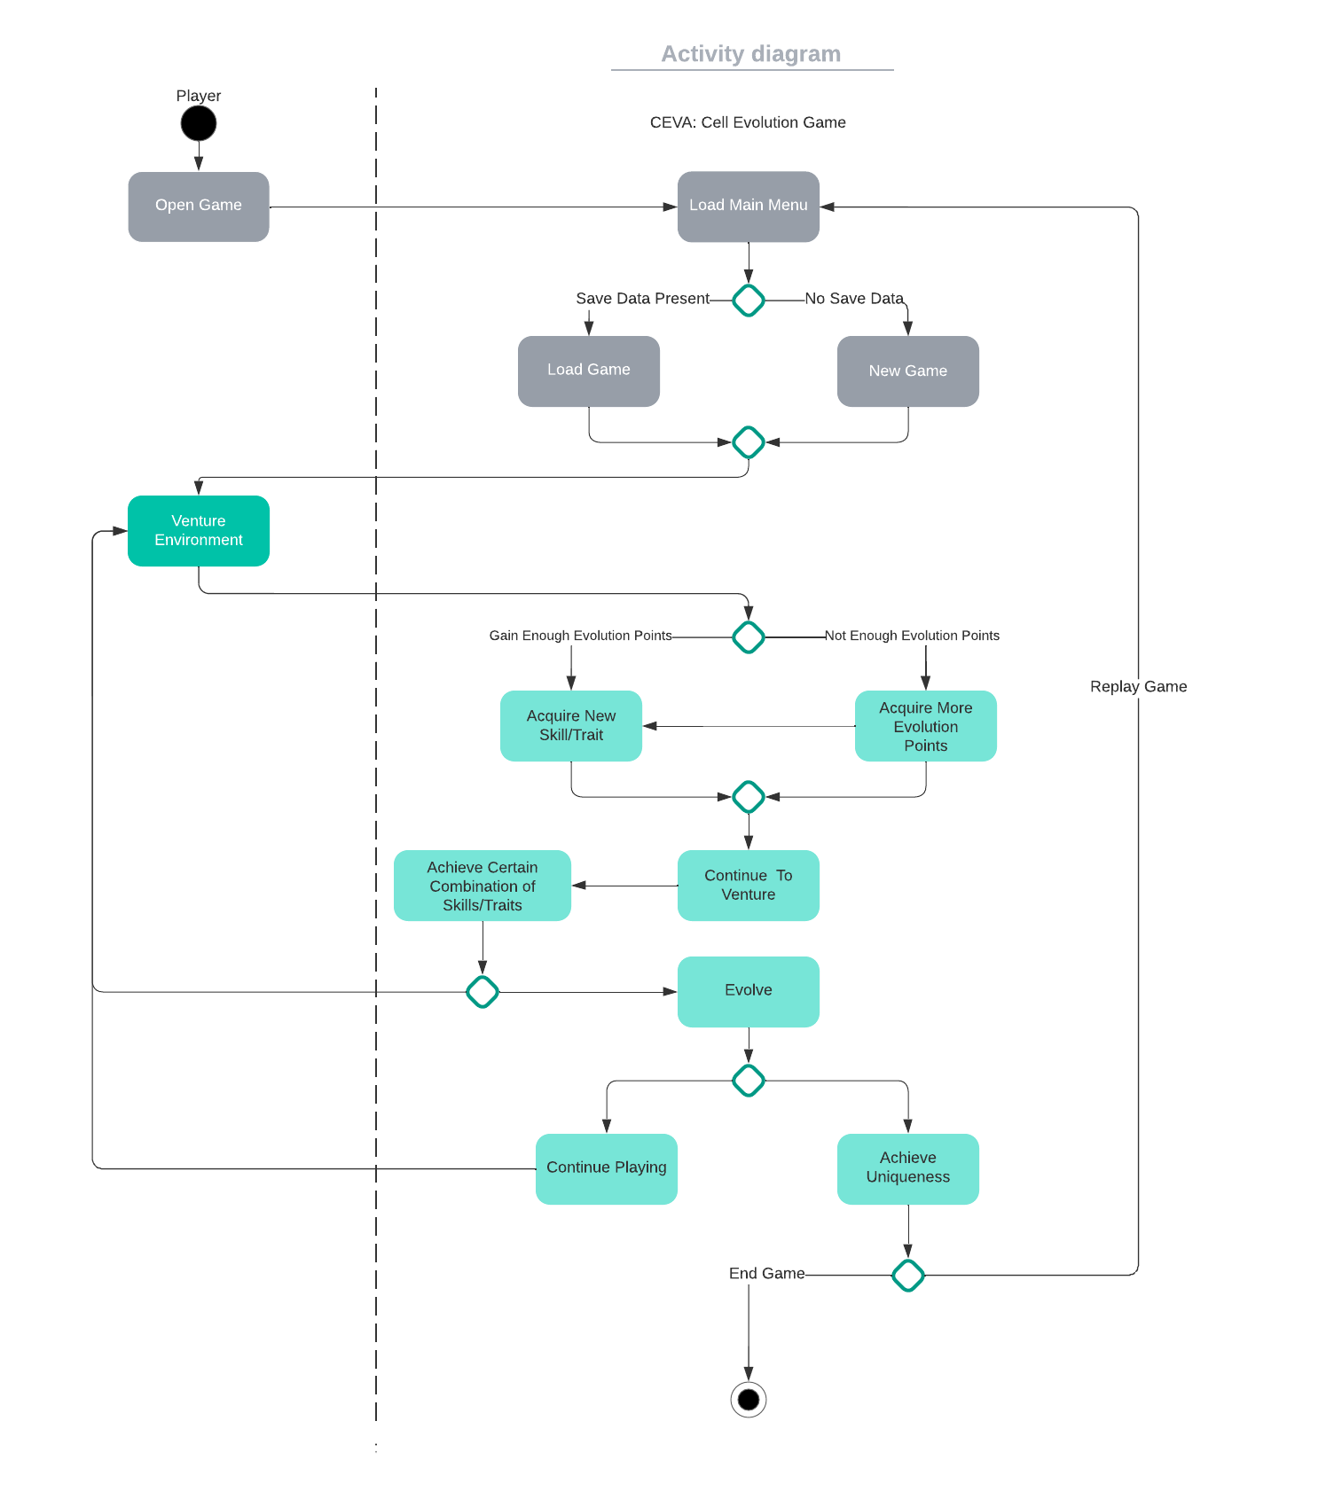

Figure 6. Activity Diagram

*System Development Life Cycle*

The researchers used GDLC or the Game Development Life Cycle which is aligned with the proposed system. It uses agile GDLC to show the iteration and repeating method when the researchers develop the proposed system. This allows the researchers to divide each process in order to develop the application with different functions at the same time. It can also help the researchers create or add some changes in the system. As shown in the figure, the agile GDLC compose of the following stages:

Figure 7 shows the GDLC of the proposed system.

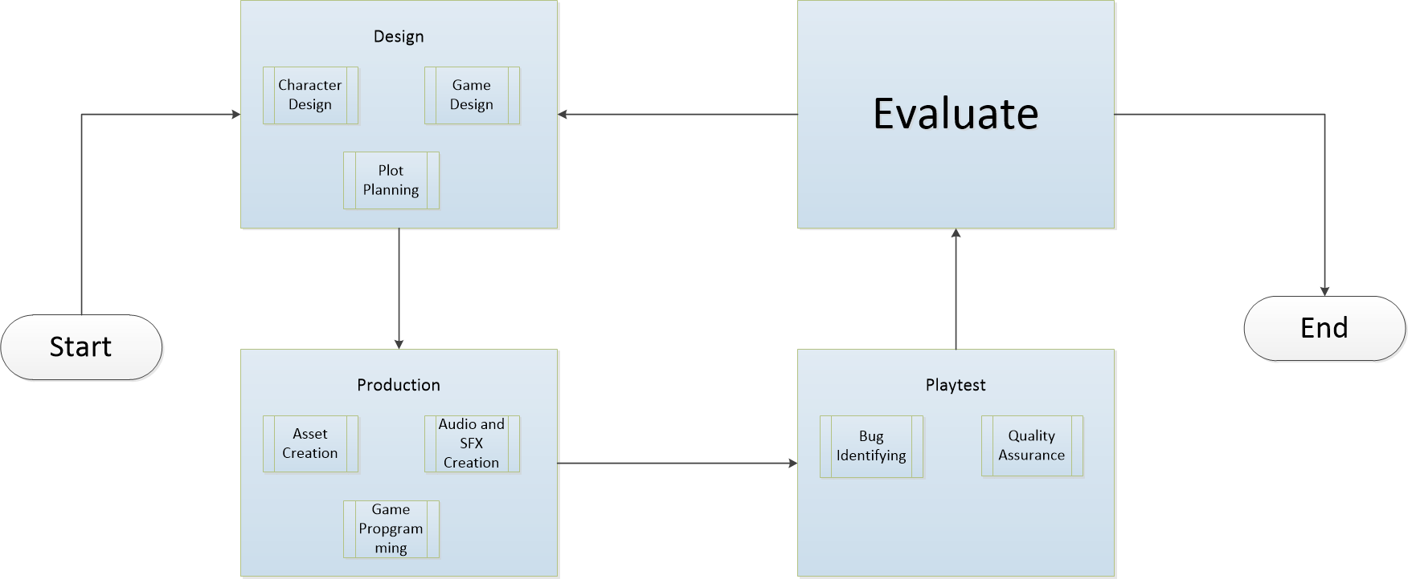

Figure 7: Game Design Life Cycle

Design Stage — in the design stage, the researchers make the character design of each cell, enemy cells, and the skill of each cell. Each design is based on the actual image of the cell in the primitive state of the world. Researchers also plan the whole game’s rundown in order to show the overall product of the application.

Production stage – in the production state, the researchers create the assets of the game depending on the character design that the researchers drew. In this stage the programmer started to develop the game and study all the needed functionalities of the game, and lastly the researchers found the audio and special effects related to the game in order to be more appealing.

Playtest – in this stage, the researchers find the bugs that are inside the game. The programmer debugs all of the bugs found in the game. Also the researchers conduct a quality assurance to the users in order to make some changes that the user suggested.

Evaluate – the evaluate stage, the researcher conducts a survey to the user in order to know the quality of the game and if it is ready to deploy in the market.

CHAPTER 4 RESULTS AND DISCUSSION

Implementation

The proposed system was implemented to test it as an educational tool.

The software underwent several stages during development. Firstly, determining the programming language and game engine to use to develop the proposed system was performed. Next was the conception of the game mechanics and overall game play loop. Furthermore, the researchers also created and developed assets, background images, etc. for the graphics.

The experimental run of the system and its functional operations: the mouse navigation where the user or player controls the protagonist in order to navigate the environment. The system interprets the user’s action and the game corresponds to the action of the player.

The system testing was done in three ways: the developer’s testing, expert’s testing and user’s testing to make sure that the game and its functionality is what is anticipated.

Finally, maintaining the system, the researchers are responsible for giving the user the knowledge on how the system will work. A tutorial phase and a user guide is available inside the game in order to teach the player on how to play the game.

Systems Inputs and Outputs

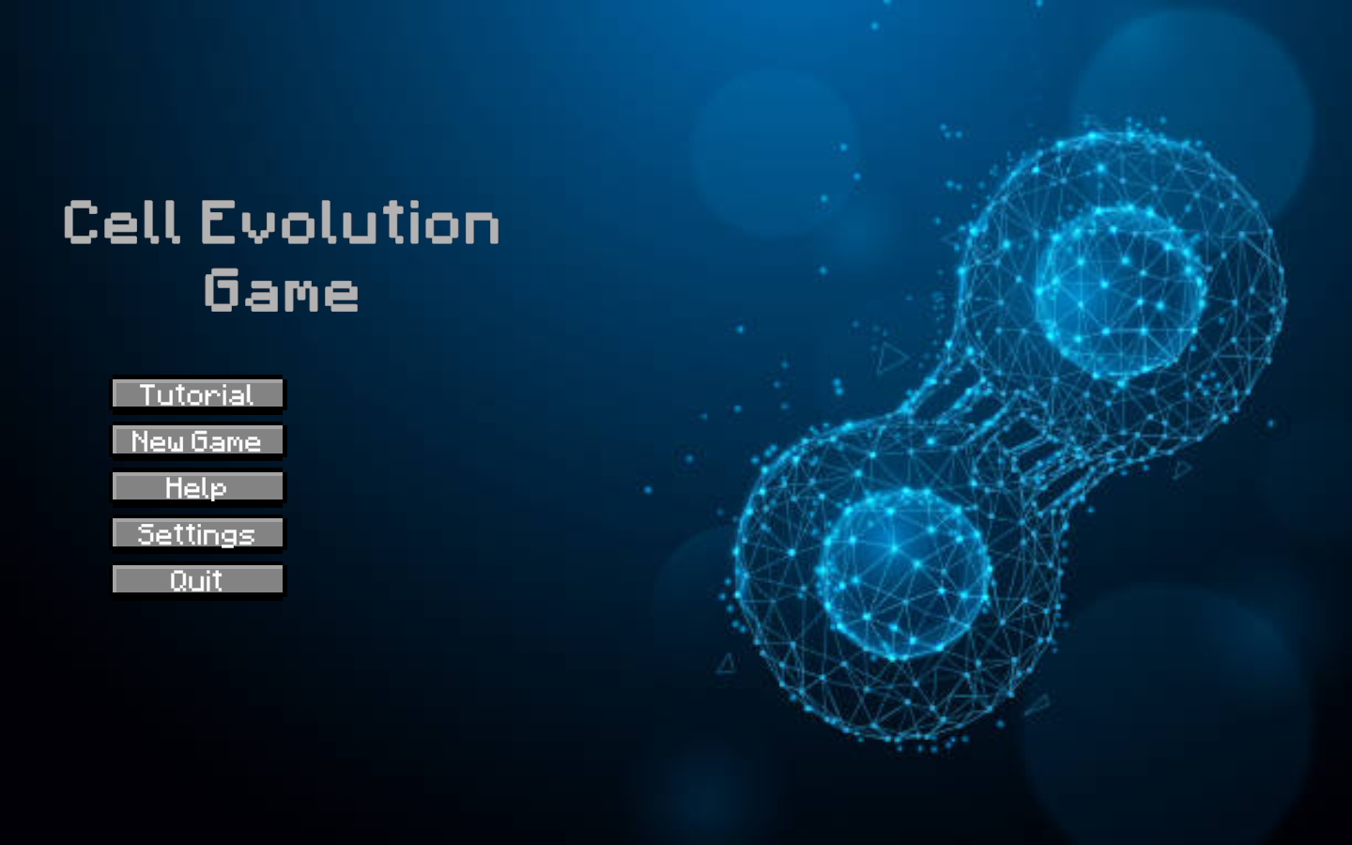Figure 8. Main Menu Screen

Figure 8 shows the main menu screen of the Cell evolution Game. It is the introduction screen when the user opens the application. It has 5 buttons which can redirect you to different screens.

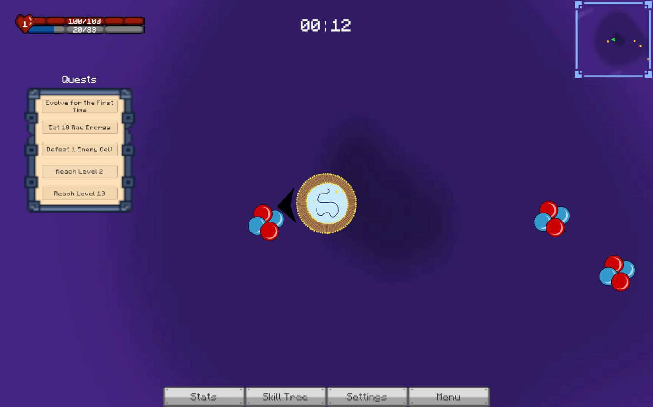

Figure 9. Main Game

Figure 9 shows the game where you spawn. In this mode, you collect energy food which turns into Experience points and you will try to survive in the horde of enemies. There are quest in which you can clear it by completing the each quest

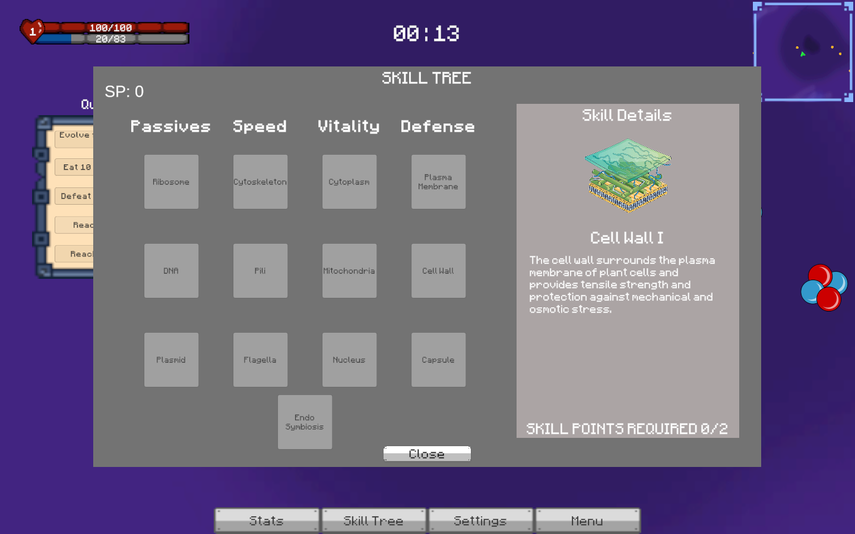

Figure 10. Skill Tree

The figure 10 shows the skill tree of the game. it shows the different skills that needed to be leveled depending on what type of cell you evolved. It has also description of the skill that you wanted to evolved

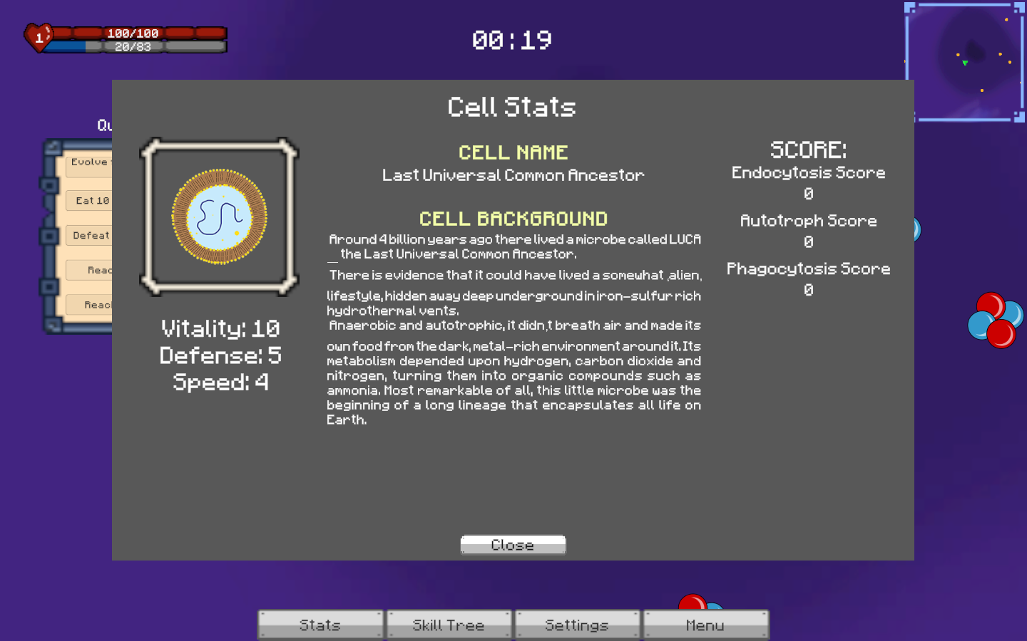

Figure 11 Stats of the cell

Figure 11 shows the overall statistics of your cell. It has background information of the cell that you have chosen. it also shows your score, your statistics when you skill up.

Results Interpretation and Analysis

To evaluate the system, a sample of 9 respondents which are students ranging from Senior High School Grade 11 up to 1st-year college major in biology. The system is a game on a computer, they will use the researcher’s laptop in order to play the game.

In order to know the result of the evaluation, the researchers used the skills and specific cell evolution that the player chose as a basis for the player’s progress through the first stage to the last. The researchers divided the questions depending on the category. First, the question related to the system if it is ready to release, and lastly the question related to the experience of the player with the system.

For the question related to the system, if the player or the respondents continue to eat and accumulate points in order to evolve, eventually it will go to the next stage and start to gain some evolution points. If the player chooses to eat and does not evolve, they will be stuck on that specific level. In the end, if the player chooses to eat over again and decides not to evolve, they will remain in that stage with many evolution points to spare. And if the player decides to evolve, they will have a choice to proceed to the next stage with a different environment and enemies.

For the experience of the player, the researchers have a set of questions regarding the experience of the player. The researchers gathered the data and proceeded to compute the result with the use of descriptive statistics, specifically the mean and standard deviation.

| Level  1  2  3  4 | Mean  3.5  3  3.25  4 |
| --- | --- |

Table 1. In-game Evaluation results

The results showed that Level 4 is the highest mean score with 4.75 indicating a Very High mean score, where Level 4 is the most interesting part and the other levels are Medium to High.

| Mean  1.00 – 1.50  1.51 – 2.50  2.51 – 3.00  3.51 – 4.00 | Interpretation  3.5  3  3.25  4 |
| --- | --- |

Table 2. Mean Score Interpretation

The result of the system shows that the game is an alternative tool for teaching cell evolution to students. The system also shows that if it is implemented, it can be used by parents, teachers, and students in order to learn more about cell evolution.

System Evaluation Results

The system with a mean score of “Very High” and “High” interprets it as an effective tool for teaching cell evolution using alternative methods. The system focuses on evaluating the “Functional Suitability”, “Performance Efficiency”, “Usability”, “reliability”, and “Portability”. These aspects of the educational game where it will be tested with the five mentioned as a tool to evaluate the game.

For device compatibility, the game is in Windows 7 and above as an OS requirement. The respondents’ computers did not have an issue with the compatibility of the system.

The system evaluation was conducted to 9 Senior High School students majoring in STEM and Biology Students. The researchers sent a letter to the respondents and the data was collected and analyzed through ISO 25010 evaluation form with the application attached.

Table 3

ISO 25010 - Functional Stability



Functional Stability. The results shown on table 3 indicate that the system is “Outstanding”. The Completeness and appropriateness shows that their mean is 4.2, while the correctness is 4.3. The application exhibits that the required functions are met with standards.

Table 4

ISO 25010 - Performance Efficiency



Performance Efficiency. The results show in table 4 that the performance of the application is met. In the “Time behavior”, its mean shows the average of 4.7 and the “Resource Utilization” also produces the same result with 4.7 which is an “Outstanding. while the “Capacity shows a 4.3 average.

Table 5

ISO 25010 - Usability



Usability. In this table the “Appropriateness Recognizability" and the “Learnability” have the same mean of 3.7. “User Interface Aesthetics” and "Operability” also have the same mean of 4.5 which is “Outstanding”. Lastly, the “User Error Protection” has a mean of 4.5. It indicates that the application’s usability is recognized.

Table 6

ISO 25010 - Reliability



Reliability. The “Maturity” indicates that the mean of 4.1 is “Very Satisfactory”. While “Recoverability” has the mean of 4.5. The “Fault Tolerance" has a mean of 4.3. The table shows that the Reliability of the application met its standard.

Table 6

ISO 25010 - Portability



Portability. In this table, the “Adaptability: has a mean of 4.1 which is “Very Satisfactory" and the “Installability" has a mean of 4.3 which is also “Very Satisfactory”. The portability of the application is dependent on the specifications of the user’s device which sometimes affect the application’s overall performance.

Table 6.

Summary of ISO 25010



Legend:

    Scales of Mean     Description

5 - 4.1 Outstanding

4 – 3.1 Very Satisfactory

3 – 2.1 Satisfactory

2 – 1.1 Fair

  1 Poor

The results shown in table 6 demonstrate that the cell evolution game has attained an overall rating of “Outstanding” based on the ISO 25010 standard with the overall mean of 4.28. Among the requirements, the Performance Efficiency has the highest mean total which is equal to an “Outstanding” rating. The remaining requirements also have an “Outstanding” requirement rating.

Results have met the quality evaluation criteria and so the application’s suitability is indeed met the user’s need.

CHAPTER 5 Summary, Conclusions, and Recommendations

Summary of the Proposed Study Design and Implementation

This study developed a game application that focuses on cell evolution. The application itself teaches the student in biology the different evolutionary paths of cell evolution, with this students can learn and understand the cell evolution.

The user firstly opens the application and can navigate through the different buttons in the main menu. The user can start the application and the game and the will direct you to the screen where the game will start and the instructions on how the game will be played will be shown on the screen. As the game progresses, the skill of the cell will be available to the player and will select the desired skill in order to survive in the game. The game can be played on a PC with the specifications of Windows 7 and above with a processor of higher speed and 4GB memory of RAM.

The development process of the application was made in Unity 3D as a platform for creating the game and using the visual code for the coding part.

This study will have an impact on the students taking biology as their major course. This application will help them understand further the cell evolution and what is the different cell in the past and how they evolve as of now. The simulation game will simulate the cell and how they consume the nutrients in order to survive. In addition to this, it will also help the teachers on how they approach teaching the cell evolution. This will be a teaching tool for them in order to convey the different cells in the past.

Summary of Findings

The cell evolution game was developed in order to help students ranging from senior high school to college to understand how the cell evolves into different paths and how each cell interacts with its food and its different body parts in order to survive in the harsh environment that they lived in.

The game is still subject to improvements that will further upgrade its capabilities in the future. This improvement is composed of adding new evolution paths so it can further understand the other cell evolution and tackle the homo sapiens genome. This also includes the improvements of the skills based on the chosen path which confuses the user with complicated issues.

Conclusions

When the implementation and testing has done, the results of the proposed game application were obtained and met its objectives:

1. A simulation game that focuses on different cell evolution in which the user can choose an evolutionary path and its dynamic environment that can simulate the harsh environment which the cell encountered long ago.
2. Different Cell evolution concepts have been implemented to the game and turn it into narrative gameplay and mechanics. The different cell evolution concepts is one of the main features of the game and it has successfully been absorbed into the game.
3. The gameplay choice of the user can be seen and it has the stats button in which the user can view its dietary path and evolutionary path. This concept can be viewed by the user and review their chosen path and the skills that they acquired.

Recommendations

The following recommendations are suggested based of the observations and conclusions presented:

1. To include a new additional evolutionary path so that the user can explore different paths.
2. To include new enemies that are not found in the environment in order to have a harder experience.
3. To add animations to the cells so it can appeal to the user’s eyes.
4. to include an evolutionary path in which the evolved cell turns into a mammal or plants.

References

*Bodyl, A., Mackiewicz, P. (2013) Endosymbiotic Theory. Retrieved from January 25, 2023 from https://depot.ceon.pl/bitstream/handle/123456789/3286/Endosymbiotic%20Theory.pdf?sequence=1*

# Boller, S. (2014). Games vs Simulations: Choosing the Right Approach for Learning. Retrieved January 25, 2023 from http://www.theknowledgeguru.com/games-vs-simulations-choosing-right-approach/

Cooper, G. (2000). The Origin and Evolution of Cells. Retrieved January 2023, from https://www.ncbi.nlm.nih.gov/books/NBK9841/

*Cell Theory*. (2020, August 15). https://bio.libretexts.org/@go/page/12710

Electronic Arts. (2008). Spore (PC Version) [Video Game]. Maxis

Ellington H, et al (1998). Using Games and Simulations in the Classroom. Routledge

*First Cell*. (2020, October 05). CK-12. https://flexbooks.ck12.org/cbook/ck-12-biology-flexbook-2.0/section/5.4/primary/lesson/first-cells-bio/

Georgia Tech Biological Sciences. (n.d.). *Prokaryotes: Bacteria & Archaea.* Retrieved January 16, 2022 from https://organismalbio.biosci.gatech.edu/biodiversity/prokaryotes-bacteria-archaea-2/

Harris, J. (n.d.) Phagocytosis. Retrieved Janaury 23, 2023 from https://www.immunology.org/sites/default/files/2022-08/Phagocytosis.pdf

Markgraf, B. (2019, June 04). *Abiogenesis: Definition, Theory, Evidence & Examples.* Sciencing. https://sciencing.com/abiogenesis-definition-theory-evidence-examples-13719058.html

National Gepgraphic. (n.d.). Cell Theory. Retrieved January 25, 2023 from https://education.nationalgeographic.org/resource/cell-theory/

Phagocytosis. (n.d.). Khan Academy. Retrieved January 12, 2022 from https://www.khanacademy.org/test-prep/mcat/cells/transport-across-a-cell-membrane/a/phagocytosis

Quasar. (n.d.). Species: Artificial Life, Real Evolution. Retrieved January 25, 2023 from https://store.steampowered.com/app/774541/Species_Artificial_Life_Real_Evolution/

Ruben, B. D. (1999). Simulations, Games, and Experience-Based Learning: The Quest for aNew Paradigm for Teaching and Learning. Simulation & Gaming, 30(4), 498–505.https://doi.org/10.1177/104687819903000409

Sinicki, A. (2017) Learn Unity for Android Game Developer. Retrieved January 25, 2023 from https://www.google.nl/books/edition/Learn_Unity_for_Android_Game_Development/ytUtDwAAQBAJ?hl=en&gbpv=1&pg=PR1&printsec=frontcover

# Vlachopoulos, D., Makri, A. (2017). The effect of games and simulations on higher education: a systematic literature review. Retrieved January 25, 2023 from https://educationaltechnologyjournal.springeropen.com/articles/10.1186/s41239-017-0062-1

Warring, S. (n.d.). *Endosymbiotic Theory.* Ask A Biologist. Retrieved January 12, 2022, from https://askabiologist.asu.edu/explore/cells-living-in-cells

Woose, C. (2002). On the Evoulution of Cells. Retrieved January 25, 2023 from https://www.pnas.org/doi/10.1073/pnas.132266999

Yannakakis, G., Hallam, J. (2004) Evolving opponents for interesting interactive computer games. Retrieved January 25, 2023 from https://www.um.edu.mt/library/oar/handle/123456789/22948

Appendices

Appendix A

Letter to the Adviser

February 3, 2022

**Mark Joseph J. Solidarios**

Instructor I

West Visayas State University

Luna St. La Paz, Iloilo City

Dear Mr. Mark Joseph J. Solidarios,

The undersigned are BS Information Technology Research 1/Thesis 1 students of CICT, this university. Our thesis/capstone project title is *“An Interactive Simulation Game for Teaching for Teaching Cells”.*

Knowing of your expertise in research and on the subject matter, we would like to request you to be our **Thesis** **Adviser**

We are positively hoping for your acceptance. Kindly check the corresponding box and affix your signature in the space provided. Thank you very much.

PS:

*Advisers, are task to work with the students in providing direction and assistance as needed in their thesis/capstone project. They shall meet with the students weekly or as needed to provide direction, check on progress and assist in resolving problems until such a time that the students passed their defenses and submit their final requirements, as well as, preparing their evaluations and grades.*

| Action Taken:  🔾 I Accept.  🔾 Sorry. I don’t accept. |  |
| --- | --- |
| Signature over printed name of the Adviser |

CC:

CICT Dean

Research Coordinator

Group

*\*To be accomplished in 4 copies*

Appendix B

Letter to the Evaluators

Dear Respondents,

Good Day,

We, the researchers of West Visayas State University; College of Information and Communication, would like to formally invite you to be our respondents in our research entitled: A Simulation Game for Teaching Cell Evolution. Your participation will greatly help improve the system.

We are anticipating your most positive response to help in answering our survey through Google Forms for the improvement of our proposed research study.

We are hoping for your favorable response.

Thank you very much for your continued support.

Researchers:

De la Cruz, Uriah

Debuque, Paul Joseph

Panganiban, Jeric Glen

Parcon, Zoreen

Vargas, Leslie Marie

Appendix C

Letter to the Grammarian

May 4, 2022

**NAME**

Position

West Visayas State University

Luna St. Lapaz, Iloilo City

Dear Prof.,

The undersigned are BS Information Technology Research 1/Thesis 1 students of CICT, this university. Our thesis/capstone project title is “An Interactive Simulation Game for TEaching Cell Evolution”.

In line with this, we would like to request you to be our **Thesis Grammarian**. We believe that your expertise in this area will significantly improve our study.

We are positively hoping for your acceptance. Kindly check the corresponding box and affix your signature in the space provided. Thank you very much.

Respectfully yours,

1. Uriah De La Cruz

2. Paul Joseph Debuque

3. Jeric Glen Panganiban

4. Zoreen Parcon

5. Leslie Marie Vargas

| Action Taken:  🔾 I Accept.  🔾 Sorry. I don’t accept. |  |
| --- | --- |
| Signature over printed name of the Adviser |

Appendix D

Gantt Chart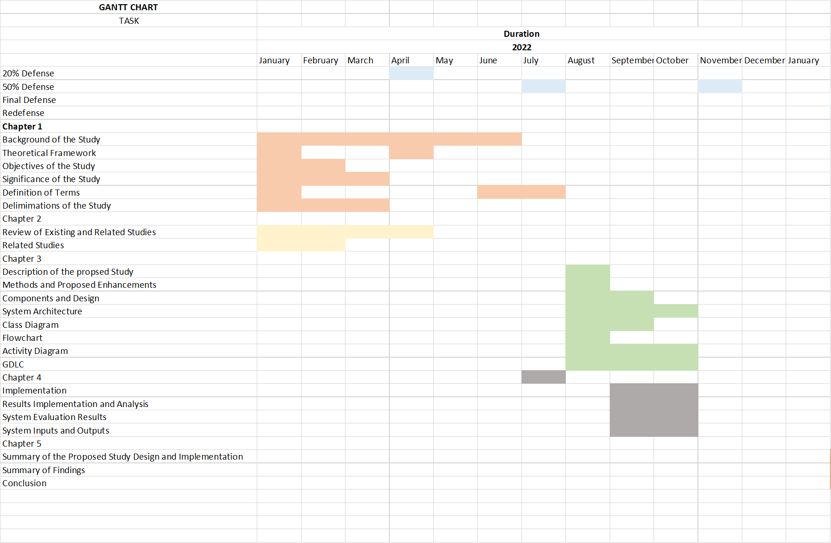

Appendix E

Source Code

using System.Collections;

using System.Collections.Generic;

using UnityEngine;

public class CellClassChecker : MonoBehaviour

{

public PlayerStats stats;

[Header("Game Objects")]

public GameObject Crenarchaeota;

public GameObject Euryarchaeota;

public GameObject Cyanobacteria;

public GameObject Proteobacteria;

public GameObject Plant;

public GameObject Animal;

public GameObject Fungi;

public GameObject Protist;

// [Header("")]

void Update()

{

if (stats.currentCellClass == "Crenarchaeota Cell")

{

Crenarchaeota.SetActive(true);

Destroy(Euryarchaeota);

Destroy(Cyanobacteria);

Destroy(Proteobacteria);

Destroy(Plant);

Destroy(Animal);

Destroy(Fungi);

Destroy(Protist);

} else if (stats.currentCellClass == "Euryarchaeota Cell")

{

Euryarchaeota.SetActive(true);

Destroy(Crenarchaeota);

Destroy(Cyanobacteria);

Destroy(Proteobacteria);

Destroy(Plant);

Destroy(Animal);

Destroy(Fungi);

Destroy(Protist);

} else if (stats.currentCellClass == "Cyanobacteria Cell")

{

Cyanobacteria.SetActive(true);

Destroy(Euryarchaeota);

Destroy(Crenarchaeota);

Destroy(Proteobacteria);

Destroy(Plant);

Destroy(Animal);

Destroy(Fungi);

Destroy(Protist);

} else if (stats.currentCellClass == "Proteobacteria Cell")

{

Proteobacteria.SetActive(true);

Destroy(Euryarchaeota);

Destroy(Cyanobacteria);

Destroy(Crenarchaeota);

Destroy(Plant);

Destroy(Animal);

Destroy(Fungi);

Destroy(Protist);

} else if (stats.currentCellClass == "Plant Cell")

{

Plant.SetActive(true);

Destroy(Euryarchaeota);

Destroy(Cyanobacteria);

Destroy(Proteobacteria);

Destroy(Crenarchaeota);

Destroy(Animal);

Destroy(Fungi);

Destroy(Protist);

} else if (stats.currentCellClass == "Animal Cell")

{

Animal.SetActive(true);

Destroy(Euryarchaeota);

Destroy(Cyanobacteria);

Destroy(Proteobacteria);

Destroy(Plant);

Destroy(Crenarchaeota);

Destroy(Fungi);

Destroy(Protist);

} else if (stats.currentCellClass == "Fungi Cell")

{

Fungi.SetActive(true);

Destroy(Euryarchaeota);

Destroy(Cyanobacteria);

Destroy(Proteobacteria);

Destroy(Plant);

Destroy(Animal);

Destroy(Crenarchaeota);

Destroy(Protist);

} else if (stats.currentCellClass == "Protist Cell")

{

Protist.SetActive(true);

Destroy(Euryarchaeota);

Destroy(Cyanobacteria);

Destroy(Proteobacteria);

Destroy(Plant);

Destroy(Animal);

Destroy(Fungi);

Destroy(Crenarchaeota);

}

}

}

Appendix F

ISO Questionnaire

Using the scale below evaluate the system by placing a check (✓) mark on the appropriate column.

**5**- Outstanding **4**-Very Satisfactory **3**-Satisfactory **2**- Fair **1**-Poor

1. Functional Suitability

| Indicators | | 5 | 4 | 3 | 2 | 1 |
| --- | --- | --- | --- | --- | --- | --- |
| Completeness | The set of instructions all the specified task and user objectives. |  |  |  |  |  |
| Correctness | The system provides correct results with the needed degree of precision. |  |  |  |  |  |
| Appropriateness | The system provides the accomplishment of the specified tasks objectives. |  |  |  |  |  |

2. Performance Efficiency

| Indicators | | 5 | 4 | 3 | 2 | 1 |
| --- | --- | --- | --- | --- | --- | --- |
| Time-behavior | The response and processing times and throughout rates of a product or system, when performing its functions, meet requirements. |  |  |  |  |  |
| Resource utilization | The amounts and types of resources used by a product or system, when performing its functions, meet requirements. |  |  |  |  |  |
| Capacity | The maximum limits of the product or system parameters meet requirements. |  |  |  |  |  |

3. Usability

| Indicators | | 5 | 4 | 3 | 2 | 1 |
| --- | --- | --- | --- | --- | --- | --- |
| Appropriateness Recognizability | Users can recognize whether a product, a product or system is appropriate for their needs. |  |  |  |  |  |
| Learnability | A product or system enables the user to learn how to use it with effectiveness. |  |  |  |  |  |
| Operability | A product or system is easy to operate, control and appropriate to use. |  |  |  |  |  |
| User error protection | A product or system protects users against making errors. |  |  |  |  |  |
| User interface aesthetics | A user interface enables pleasing and satisfying interactions for the user. |  |  |  |  |  |

4. Reliability

| Indicators | | 5 | 4 | 3 | 2 | 1 |
| --- | --- | --- | --- | --- | --- | --- |
| Maturity | A system, product or component meets for reliability under normal operations. |  |  |  |  |  |
| Availability | A product or system is operational and accessible when required for use. |  |  |  |  |  |
| Fault Tolerance | A system, product or component operates as intended despite the presence of hardware or software results. |  |  |  |  |  |
| Recoverability | In the event of an interruption or what failure, a product or system can recover the data and establish the desired state of the system. |  |  |  |  |  |

5. Portability

| Indicators | | 5 | 4 | 3 | 2 | 1 |
| --- | --- | --- | --- | --- | --- | --- |
| Adaptability | A product or system can effectively and efficiently be adapted for different or evolving hardware, software or other operational or usage environments. |  |  |  |  |  |
| Installability | The product or system can be successfully installed and/or uninstalled in a specified environment. |  |  |  |  |  |

Appendix G

Disclaimer

This software project and its corresponding documentation entitled “An Interactive Simulation Game for Teaching Cell Evolution” is submitted to the College of Information and Communications Technology, West Visayas State University, in partial fulfillment of the requirements for the degree, [Degree Program Here]. It is the product of our own work, except where indicated text.

We hereby grant the College of Information and Communications Technology permission to freely use, publish in local or international journal/conferences, reproduce, or distribute publicly the paper and electronic copies of this software project and its corresponding documentation in whole or in part, provided that we are acknowledged.

Uriah De La Cruz

Paul Joseph Debuque

Jeric Glen Z. Panganiban

Zoreen Parcon

Leslie Marie Vargas

May 2023